New Dawn

Story

Mursaat (non playable)
Now outcasts from Tyria the Mursaat sought refuge in a new land, Ocullia. The Mursaat went unseen for decades. However their lust for power grew and gained knowledge of an ancient power to the east. Little did they know, by unlocking this power they had unleashed a great evil upon the land and corrupting half their race to the side of great evil.
The Mursaat Queen been greatly effected by her people now is torn between good and evil and this shows in her appearance as well.
Main char: Mursaat Queen

Satyrs (Kind of anti paragon)
Half man-half goat (playable)
Before the Mursaat unleashed the evil power, these were a peace loving race, which prided themselves on their music. However now corrupted by evil, they hunger for war and bloodshed. They wield morning stars and their main power is to corrupt those around them.
Some Skills thought of:
Reversal of healing: For 10-20 seconds a targeted foe gets the reverse affect from healing.
Turncoat: For 10-20 Seconds the targeted foe turns coat and cannot attack you or your allies however can be attacked by his own allies.
Main Character: Satyr demon lord. Wields skull morning star. (Like from the cinematic in prophecies but I don’t think we ever fight him, do we? Looks cool anyway.)

Engineers (Like rangers)
Pirates (playable)
A technologically advanced race however untidy and random there appearance and cities may be. This race has developed the first black powder weaponry known in the guild wars world and their main weapon is kind of a blunderbuss. Because their sight is commonly impaired at birth they always wear goggles to help improve their sight.
This enabled them to spot the Mursaat intruders on their land and our now at war with the Mursaat. Little do they know that the Mursaat are caught in the middle and are unwilling to surrender to anyone as their Queen has gone insane.
Some Skills thought of:
Pack a punch: preparation for 20 seconds. Shots do double damage and foe is knocked down, however so are you from recoil.
Black-powder overload. Single shot that does 60 damage. 5-10% chance of jamming and blowing up in your face causing damage to you.
Rest can be like marksmanship but for guns.
Main character: Leader of engineers. Has patch on eye and wields two pistols.

New idea
Mounts for Guild wars characters. Could be like pets that you ride that take 70% of damage inflicted and you move 10 or 20% faster while mounted. Once mount dies your on foot. This would be good, then you can make stronger enemies and it would defiantly make people buy the game.

Game structure:
- Player can choose to be good or evil.
- If player chooses Satyr they are automatically evil and if engineer they are good.
Only old Character types can play both sides.
- Satyr and engineers get secret solo mission to fight Mursaat Queen. They get points for how well they do which will help them in last mission

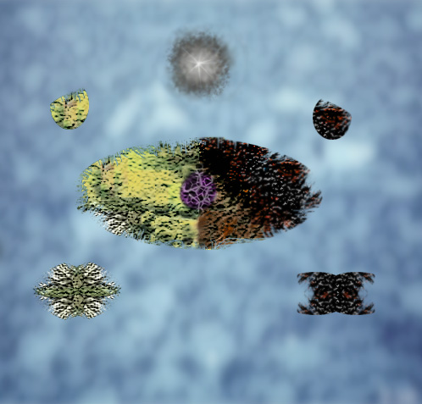
Island to decide Good or Evil
Evil New Character Island
Good New Character Island
Good end Reward Island
Evil end Reward Island
Mursaat hive
Satyr Territory
Engineer Territory

End mission
PvP match with Good Main Char Helping Good Side
Small Pve mission to get into Good Stronghold
PVP battle with Mursaat Queen on the team that has the most points from secret mission. Then she turns to which ever team adds more points by holding the flag point.
Small Pve mission to get into Evil
Stronghold

PvP match with Evil Main Char Helping Evil Side

Please do not put any good loot on the last mission. Could you do it like factions where you get one reward for doing it?
It would be very unfair if people used at as a looting ground and not let other people complete the end mission.

…and that’s the jist of my idea.

